

a class of metals and compounds whose resistance decreases to zero when they are below a certain temperature Tc, known as the critical temperature.

These materials are known as **superconductors.**

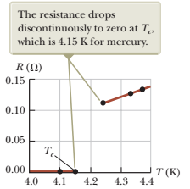 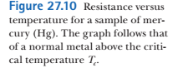

Types of semiconductors:

Metals

HTSC – high temperature superconductors: ceramics ( Copper Oxide layers connected by weak links)

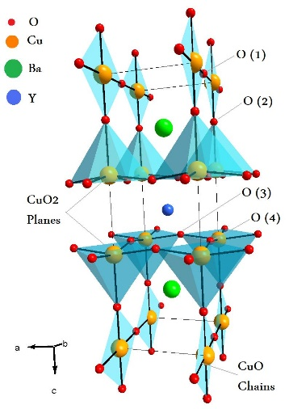 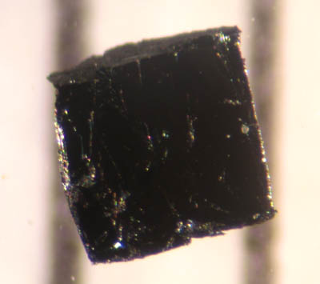

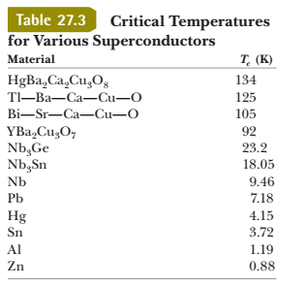 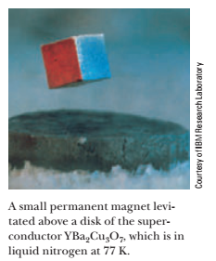

once a current is set up in them, it persists *without any applied potential difference* (because *R* = 0)

“Steady currents have been observed to persist in superconducting loops for several years with no apparent decay!”

Quantum tunneling?



In typical electric circuits, energy TET is transferred by electrical transmission from a source such as a battery to some device such as a lightbulb or a radio receiver.

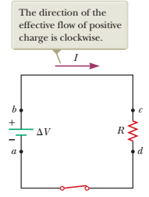 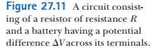

Consider a positive quantity of charge Q moving clockwise around the circuit from point a to b to c , to d, and back to a.

From point a to point b: chemical energy is transformed to electric potential energy of the charge Q:

ΔU = Q·ΔV

From c to d: drop of potential in the resistor due to ‘friction’ of the charge inside the resistor R. Energy is transformed to internal energy of the R.

When the charge return to point a : net result is that chemical energy transformed into internal energy of the resistor

the resistor loses energy via heat transfer to air and electromagnetic radiation TER

What is the rate of electric potential energy loss?



this is energy transformation: Chemical to electric potential energy to Internal energy of the resistor

the power P, representing the rate at which energy is delivered to the resistor, is



Ohm’s law:





SI unit for electric power is watt

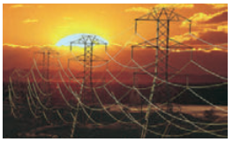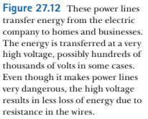

Because *P* = *I* Δ*V*, the same amount of energy can be transported either at high currents and low potential differences or at low currents and high potential differences.

P = IV – energy transferred to consumers

100 A * 100V = 1A * 104 V

In the 2nd case, energy loss is 1A*R (R – resistance of the wire)

In the 1st case: 100A *R – 100 times larger

In some instances, power is transported at potential differences  
as great as 765 kV

At the destination of the energy, the potential difference is usually reduced to 4 kV by a device called a transformer. Another transformer drops the potential difference to 240 V for use in your home

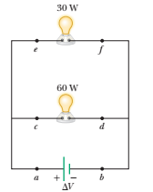 





An electric heater is constructed by applying a potential difference of 120 V across a Nichrome wire that has a total resistance of 8.00 ohm. Find the current carried by the wire and the power rating of the heater

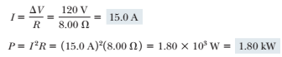



An immersion heater must increase the temperature of 1.50 kg of water from 10.0°C to 50.0°C in 10.0 min while operating at 110 V.  
**(A)** What is the required resistance of the heater?

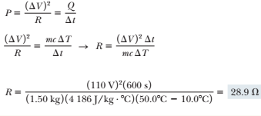





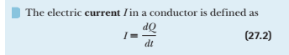



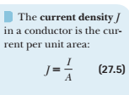

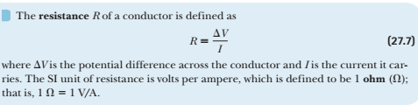



average current:



Ohm’s law:

V = I R, or



σ - conductivity



where ρ = 1/σ – resistivity

*Classical (Drude) model of electrical conduction in metals:*

electrons form an “ideal gas”

When E-field is applied, electrons move with a drift velocity that is opposite the electric field **E**



according to this model, the resistivity is:



temperature dependence of resistivity for many materials (metals):



α – the temperature coefficient of resistivity

in the circuit, power supplied to the element :



for a resistor:



QUESTIONS

**7.** A metal wire of resistance *R* is cut into three equal  
pieces that are then placed together side by side to  
form a new cable with a length equal to one-third  
the original length. What is the resistance of this new  
cable? (a) 1/9 *R* (b) 1/3*R* (c) *R* (d) 3*R* (e) 9*R*

Conceptual Questions:













